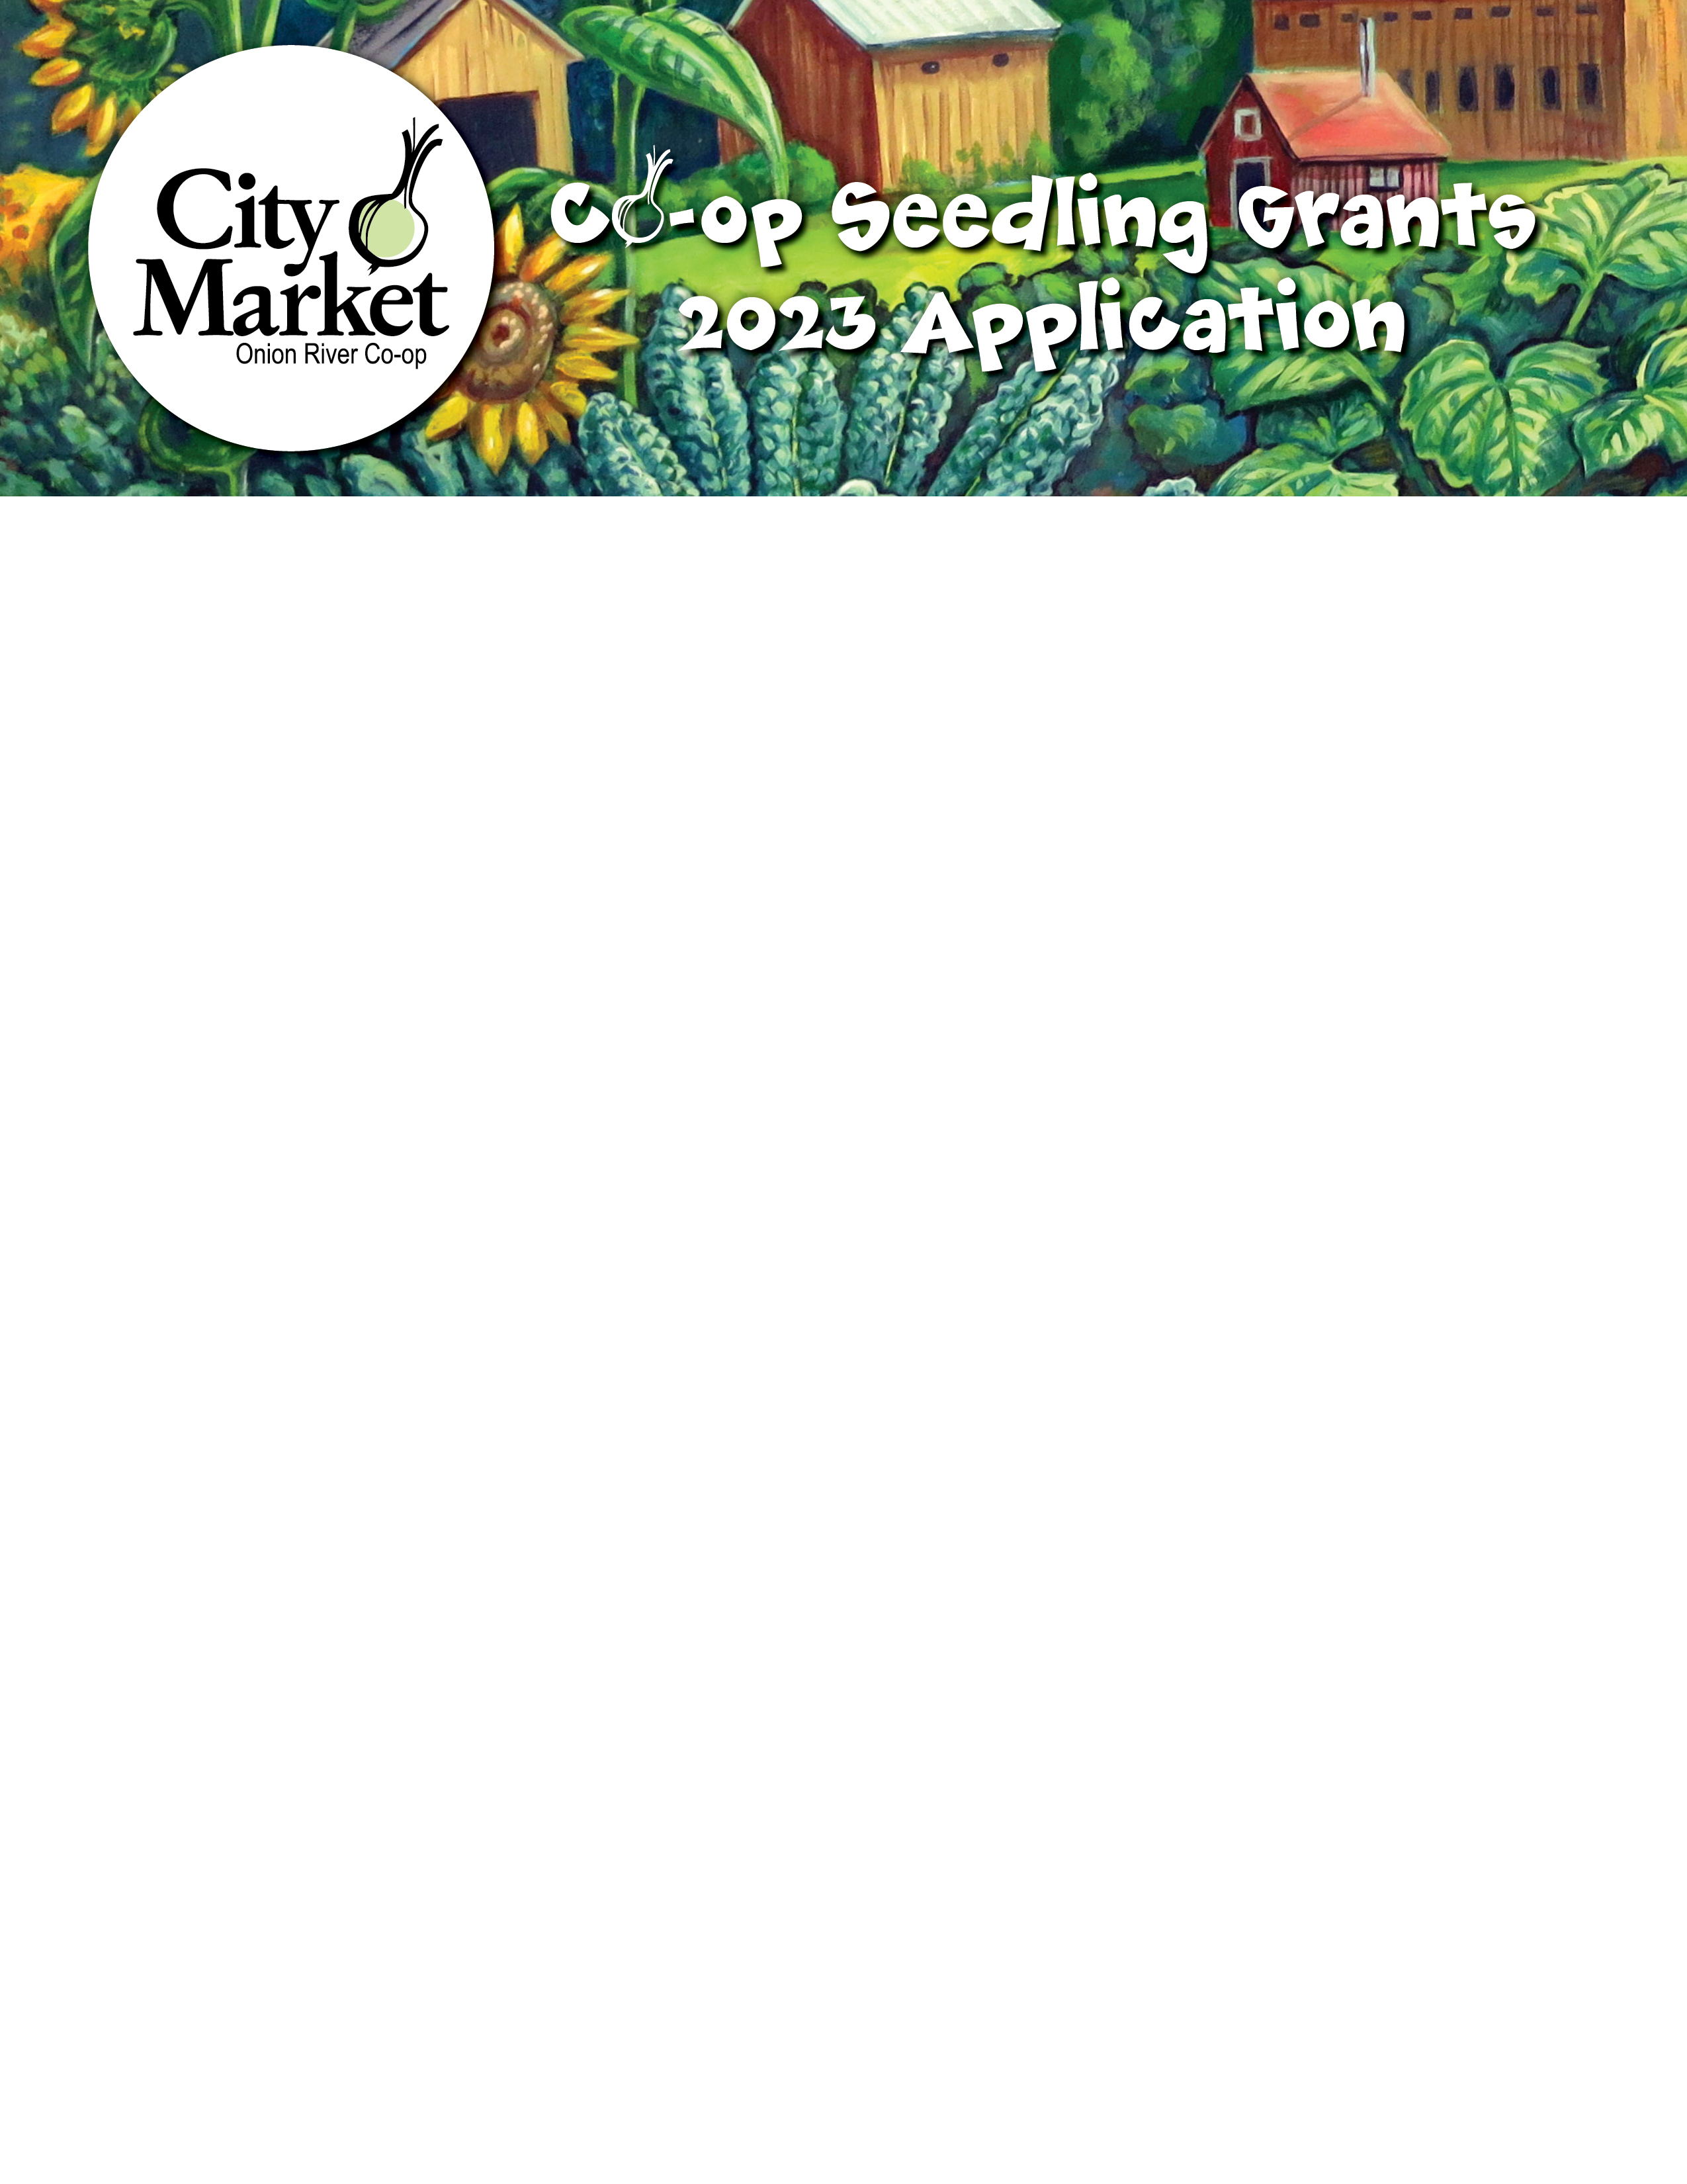

What Are Seedling Grants?

Through our Co-op Seedling Grant program, City Market grants funding to projects from Vermont non-profit organizations whose work strengthens our local food system. The Seedling Grants will be the 50% Rally for Change partner for four separate months in FY23 & FY24 to fund this year's Grants Program.

There are, of course, many interpretations of “strengthening the local food system.” Rather than narrowly defining this for applicants, we want to leave room for creativity and new ideas. Please make sure to articulate your interpretation within your application. You can find information on our successful 2022 grant recipients on our website: www.citymarket.coop/seedling-grants.

Seedling Grant History

During profitable years, City Market Members receive patronage checks based on their spending as a form of profit-sharing. According to City Market’s By-Laws, any Patronage Refunds that are not cashed within 90 days are donated to organizations supporting our local food system, as directed by our Board. In 2014, City Market created a new program to offer grants through our uncashed Patronage Refund checks – our Seedling Grant Program! Since 2018, this program has been funded through Rally for Change as the Co-op works toward a return to profitability after our South End expansion.

Some Application Tips
- We’re looking for specific, innovative projects that your organization will implement to support the local food system. Co-op Seedling Grants do not fund general operating budgets and personnel costs, nor do we donate or grant funds to individuals, partisan organizations, or organizations that advance a particular religious belief.

- We want these grants to be the answer to your unfinished sentence, “If I only had more money, I would do this…” Are there projects related to the local food system that you’ve had on the back burner or wanted to consider, but your current budget just can’t support innovation on top of the year to year must-haves and responsibilities? Please feel free to call Carrie Putscher, Assistant Outreach and Education Manager, at 802-861-9757 to ask if your project might be a good fit for this grant program.

- Share with our Member Grants Committee a unique and compelling story of your concept or project that makes us think differently. Feel free to include photos, videos, or other media in support of your written narrative.

- Remember to include in your budget a line item for contingencies and unanticipated costs. See the next page for a sample budget template.

- If you’re asking us to fund an established program, share in detail what you need to do with this program that you think you haven’t already done (and how grant funding would support that work).

The Logistics
- Applications are due no later than Friday, June 23, 2023 at 5pm. Digital applications can be submitted to grants@citymarket.coop. Hard copies can be submitted to our Customer Service desk at either our Downtown or South End locations or mailed to City Market, Attn: Carrie Putscher, 82 South Winooski Avenue, Burlington VT 05401.

- Although we would like to support every worthwhile project, due to the volume of applications and the nature of limited budgets, it may not be possible for us to fulfill every request. Please note that grants are for specific projects and we will not consider grant requests for general operating funds or personnel costs. In addition, we do not donate or grant funds to individuals, partisan organizations, or organizations that advance a particular religious belief.

- Grants will be reviewed by a committee of City Market Members and staff. This committee will then make a recommendation for grant awards to City Market’s Board of Directors. Final approval is at the discretion of City Market’s Board. The Board will review the recommendations at a fall 2022 meeting.

- Grant requests can be submitted for projects (or portions of projects) totaling $500 to $7,500.

- While we won’t know the total of the Rally for Change partnership until winter of 2023, we will allocate a minimum of $35,000 for this round of grants (pending Board approval of the awards). If the total funding is greater (based on funds raised through Rally for Change), the additional amount will be allocated equitably to recipients (based on the percentage of total already granted). Funds will be distributed to grant recipients in March 2024 during our annual celebration held at the Co-op.
- Grant applications that are not submitted, fully completed by the deadline of Friday, June 23, 2023 at 5pm will not be considered. Postmark dates do not count as receipt dates for this process.

- Grant applications will be ranked by our Member Grants Committee based on a number of factors including impact to the local food system and community, details of the planning and budget process submitted by applicants, demonstration of potential for community partnerships and collaboration, and cost of the total project versus the perceived or demonstrated impact.

Example Budget

This is a sample budget for a gardening project. Please be as specific as possible with amounts and line items for your project. We suggest soliciting quotes from providers for materials to get specific budget amounts and including the itemized quoted costs.

Budget Item | Budget Amount | City Market Grant Funded?
Plants | $437.50 | $125
Growing supplies (soil, tools) and unanticipated costs | $200 | $200
Garden rental | $60 | $60
Outreach materials | $225 | $50
Total | $1,673.25 | $435

Itemized Costs
Plants – Red Wagon Plants | Item cost | Total:
50 chives | $2.00 | $100
75 tomatoes | $4.50 | $337.50
 |  | Total: $437.50

Outreach materials | Item cost | Total:
Color copies (900) | $0.25 | $225
 |  | Total: $225

Growing supplies | Item cost | Total:
Soil – 10 bags | $5.00 | $50
3 watering cans | $4.50 | $13.50
1 hose attachment | $26.50 | $26.50
 |  | Total: $90

2023 Grant Application

Please email the completed form and appropriate documentation to grants@citymarket.coop for consideration by Friday, June 23, 2023 at 5pm. Hard copy applications may be submitted at City Market’s Customer Service counter at either store by the same date and time.

Use additional files or paper if you need to share more information than space allows below in answering any questions.

Contact Information

Contact Name:

Mailing Address:

Phone Number:

Email:

Organization Information

Name:

Executive Director Name:

Executive Director Email: Executive Director Phone #:

Mailing Address:

Website:

Non-Profit status: (please supply IRS documentation)

- Briefly describe your organization and its mission statement:

- Briefly describe your leadership team and supply an organizational chart (noting paid positions and volunteer positions) and list of Board members.

- Please attach 2 years of your organization’s financial statements and projections for the current year. If you have had an audit, please supply a copy of your most recent audit report. If these documents are available online, please provide a specific link.

Project Information

- Project title and detailed description, including projected timeline, and a list of any partner organizations (or potential partners):

- Please describe how this project will strengthen the local food system and any unmet needs you are addressing. This is an opportunity to tell your story and share your vision for this project with our Grant Committee Members who may be unfamiliar with your work:

- Grant amount requested ($500 - $7,500):

- How much money is needed in total to complete the proposed project?

- Please provide a breakdown or categorization of the total project costs and note which expenses would be covered by a City Market grant. Please be as specific as possible and note where you have actual quotes from vendors. (See example budget provided in the instructions.)

Budget Item | Budget $ | City Market Grant Funded?

- If your organization receives a City Market grant and additional project funding is needed, how do you plan to pay for the remaining expenses to complete your project?
- What are the potential costs of not moving forward with this project?
- Please define your goals for this project. What would success look like for this work? How will you measure or track that success?
- Please share how your project might be replicated for greater impact.

- If you receive a City Market grant, you will need to report back in document form within a year of funding. The report must include a description of the project for which funds were used so that City Market’s staff, Board, and Members can appreciate their contributions as well as your organization’s contributions to strengthening the local food system.

Please check here to confirm that you understand and will comply with this reporting commitment.

